1 Create a web application with register user details. Also based on email and password login to the system.

Default.aspx

using System;

using System.Collections.Generic;

using System.Linq;

using System.Web;

using System.Web.UI;

using System.Web.UI.WebControls;

using System.Data.SqlClient;

public partial class _Default : System.Web.UI.Page

{

SqlConnection con;

SqlDataAdapter sda;

SqlCommand cmd;

SqlDataReader dr;

protected void Page_Load(object sender, EventArgs e)

{

con = new SqlConnection(@"Data Source=THISPC\SQLEXPRESS;Initial Catalog=Str;Integrated Security=True");

con.Open();

}

protected void Button1_Click(object sender, EventArgs e)

{

String s = RadioButtonList1.SelectedValue;

String s1 = TextBox1.Text;

String s2 = TextBox2.Text;

String s3 = TextBox3.Text;

String s4 = TextBox4.Text;

String s5 = TextBox5.Text;

cmd = new SqlCommand("insert into reg1(username,email,dob,mobile,gender,password) values(@id1,@nm,@sellp,@rquan,@sdate,@sid)", con);

cmd.Parameters.AddWithValue(@"id1", s1);

cmd.Parameters.AddWithValue(@"nm", s2);

cmd.Parameters.AddWithValue(@"sellp", s3);

cmd.Parameters.AddWithValue(@"rquan", s4);

cmd.Parameters.AddWithValue(@"sdate", s);

cmd.Parameters.AddWithValue(@"sid", s5);

int k = cmd.ExecuteNonQuery();

}

protected void LinkButton1_Click(object sender, EventArgs e)

{

Response.Redirect("Login.aspx");

}

}

Login.aspx

using System;

using System.Collections.Generic;

using System.Linq;

using System.Web;

using System.Web.UI;

using System.Web.UI.WebControls;

using System.Data.SqlClient;

public partial class Login : System.Web.UI.Page

{

SqlConnection con;

SqlDataAdapter sda;

SqlCommand cmd;

SqlDataReader dr;

protected void Page_Load(object sender, EventArgs e)

{

// TextBox2.PasswordChar = '*';

con = new SqlConnection(@"Data Source=THISPC\SQLEXPRESS;Initial Catalog=Str;Integrated Security=True");

con.Open();

}

protected void Button2_Click(object sender, EventArgs e)

{

}

protected void Button1_Click(object sender, EventArgs e)

{

cmd = new SqlCommand("select * from reg where Cast(email as varchar) ='" + TextBox1.Text + "'and password ='" + TextBox2.Text + "'", con);

dr = cmd.ExecuteReader();

if (dr.Read())

{

Session["user"] = TextBox1.Text;

Response.Redirect("Home.aspx");

}

else

{

Response.Write("Error........");

}

}

}

O/P:-

1)Login.aspx



2) Registration.aspx

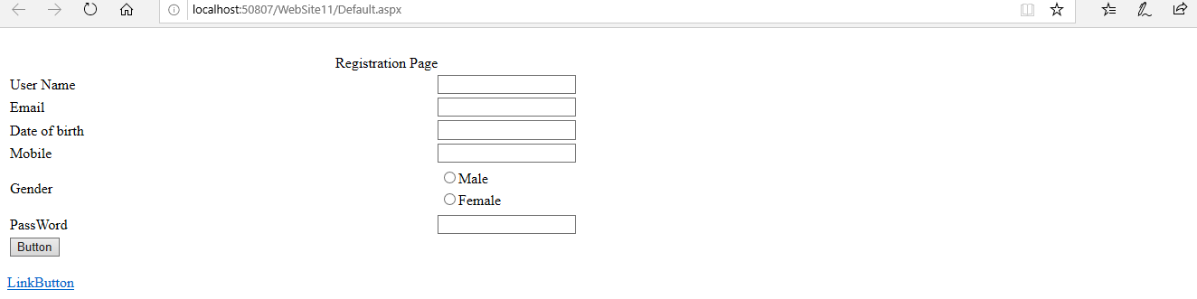

3) Welcome.aspx

